**1. Introduction**

Flow rate sensors can be useful in many purposes in industrial, agriculture and healthcare fields. There are various methods to measure flow rate. Methods can be divided into groups according to the way of taking measurements. Basically they can be divided into following groups:

1. Mechanical Flow Meters
2. Pressure Based Meters
3. Optical Flow Meters
4. Open-channel flow measurement
5. Thermal mass flow meters
6. Vortex flow meters
7. Sonar flow measurement
8. Electromagnetic, Ultrasonic and Coriolis flow meters

Every method has advantages and also disadvantages. Some of them are good for special situations and they aren’t suitable for some situations. In this project, Thermal Mass Flow Rate will be discussed.

**1.1 Thermal Mass Flow Rate Sensors**

Thermal mass flow meters generally use combinations of heated elements and temperature sensors to measure the difference between static and flowing heat transfer to a fluid and infer its flow with a knowledge of the fluid's specific heat and density. The fluid temperature is also measured and compensated for. If the density and specific heat characteristics of the fluid are constant, the meter can provide a direct mass flow readout, and does not need any additional pressure temperature compensation over their specified range. [1]

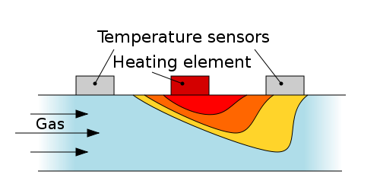

Figure 1.1 Temperature at the sensors varies depending upon the mass flow

Thermal mass flow meters measure the mass flow rate of gases and liquids directly. Volumetric measurements depend on all ambient and process conditions that make changes in unit volume or indirectly depend on pressure drop, while mass flow measurement does not depend on changes in viscosity, density, temperature, or pressure.

Thermal flow meters use the thermal properties of the fluid to measure the flow of a fluid flowing in a pipe or duct. They are often used in monitoring or controlling mass-related processes.

This meter can be used in high-pressure and high-temperature, and in special materials including glass, Monel and PFA. Flow-through designs are used to measure small flows of pure substances where heat capacity is constant, while bypass and probe-type designs can detect large flows in ducts, flare stacks, and dryers. [2]

**2. Theory**

**2.1 Thermal Mass Flow Rate Measurement**

Thermal Mass Flow Meters can operate in two different methods. They are,

* By absorbing a known amount of heat into the flow and measuring the temperature difference.
* By maintaining a constant temperature difference and measuring the amount of energy absorbed.

The components of a basic thermal mass flow meter include two temperature sensors and an electric heater between them. The heater can be inserted into the stream or it can be externally connected to the pipe.

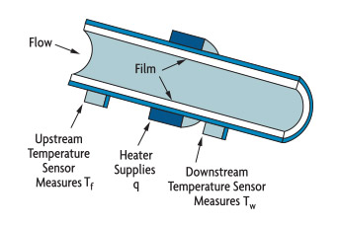

Figure 2.1.1 Externally Heated Tube

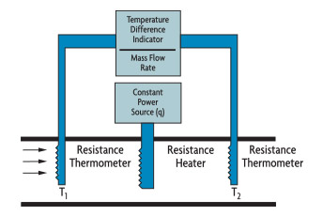

Figure 2.1.2 Immersion Heater

In the direct heat flow meter, a fixed amount of heat is supplied by an electric heater. When the fluid flows through the pipe, resistance temperature detectors (RTDs) measure the temperature rise. Then the mass flow rate is calculated by using following equation.

$$m=\frac{kQ}{Cp \left(T2-T1\right)}$$

* M - The mass flow
* T2,T1 -Temperature difference
* k - Meter coefficient
* Q - Electric heat rate
* Cp - Specific heat of the fluid

**2.2 Thermistor**

The Thermistor is another type of temperature sensor, whose name is a combination of the words THERM-ally sensitive res-ISTOR. A thermistor is a special type of resistor which changes its physical resistance when exposed to changes in temperature.

Thermistors are generally made from ceramic materials such as oxides of nickel, manganese or cobalt coated in glass which makes them easily damaged. Their main advantage over snap-action types is their speed of response to any changes in temperature, accuracy and repeatability.

Most types of thermistor’s have a Negative Temperature Coefficient of resistance or (NTC), that is their resistance value goes DOWN with an increase in the temperature, and of course there are some which have a Positive Temperature Coefficient, (PTC), in that their resistance value goes UP with an increase in temperature.

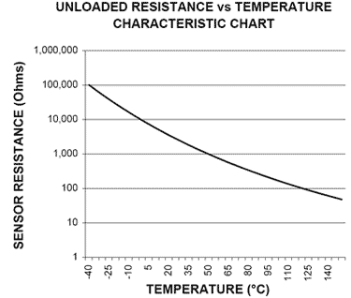

Figure 2.2.1 Resistance variation according to Temperature

**2.3 Operational Amplifier**

An operational amplifier (often op-amp or opamp) is a DC-coupled high-gain electronic voltage amplifier with an input, usually an ended output. An op-amp produces an output potential relative to circuit ground that is typically hundreds of thousands of times larger than the potential difference between its input terminals.

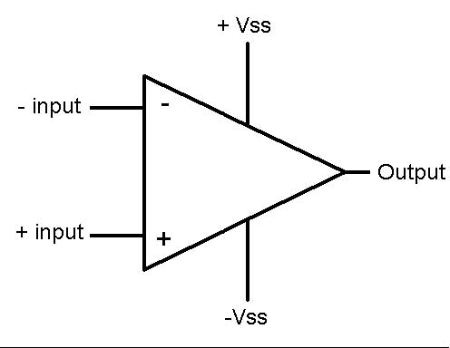

Figure 2.3.1 Block Diagram of an op-Amp

+input : non-inverting input

-input : inverting input

Vout  : output

+Vss : positive power supply

-Vss  : negative power supply

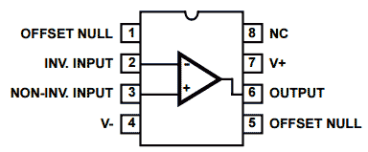

Figure 2.3.2 Pin Diagram of the op-Amp

**4. Design**

**4.1 Sensor Model**

Model was designed to hold all the components together and its design allows to change the dimensions of the model easily. (Model was designed using SolidWorks 2014.)

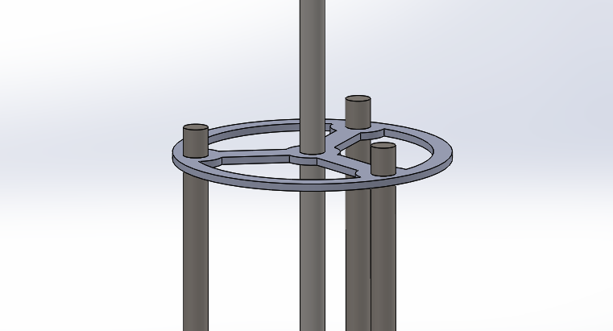

Figure 4.1.1 Design View of the sensor holder

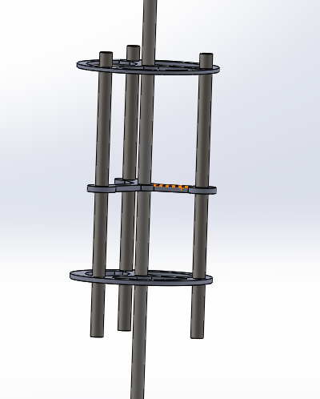

Figure 4.1 2 Design View of the sensor holder

**4.2 Circuit Diagram**

Op-amp is used to compare voltage differences from thermistors and grain them to measurable scale.

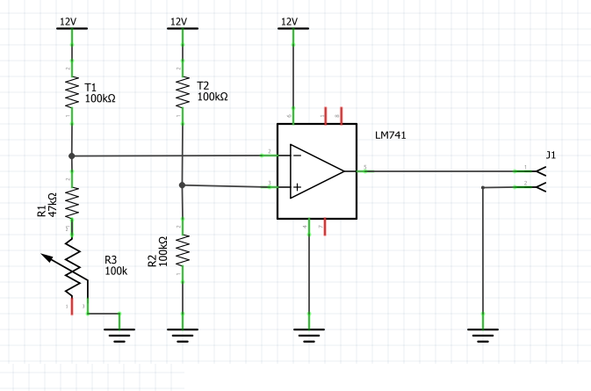

Figure 4.2 1 Circuit Diagram of the Sensor

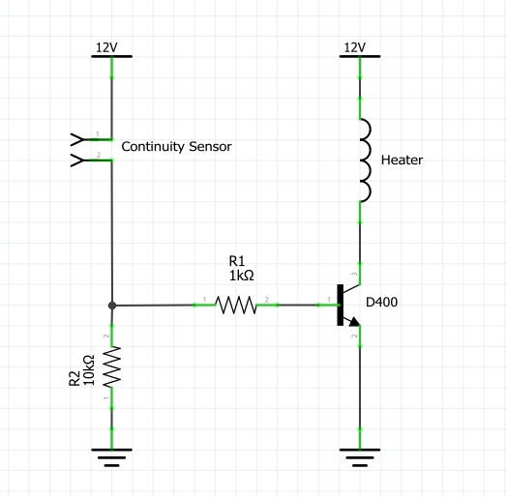

Figure 4.2 2 Circuit Diagram of the Heat Controller

**5. References**

1. <https://en.wikipedia.org/wiki/Flow_measurement>
2. <https://www.omega.com/technical-learning/thermal-mass-flow-working-principle-theory-and-design.html>
3. <https://www.omega.com/prodinfo/thermistor.html>

Latest version of the project report and project files are available on following repository

https://github.com/NuwanJ/gp108-project

